MUDASSAR MOHSIN (PHR)
Cell Phone: (571) 277-8175 • mam_mohsin@yahoo.com
(Permanent Resident of the United States of America)

Dear Hiring Manager ,

As a certified Professional in Human Resource ( PHR) and with an experience as a Human Resource Manager (Corporate and Global HR) with the 4th largest manufacturer of custom engineered power transformers in the North America, I am writing to offer your organization unmatched expertise in strategic recruitment (domestic and international) , compensation, conflict management, organizational development, including experience with foreign nationals (i.e. India & Mexico etc) and overall global Human Resources Management . Throughout my career, my expertise have directly led to improved employee relations and enhanced morale. I am confident that my employment with your team will produce the same results.

My achievements and qualifications are unparalleled, I received a special award for being the most outstanding employee of the company for the year 2010. It is because of my shining performance and achievements that within 18 months of joining the company, I have been promoted twice. I graduated Summa Cum Laude (3.99 GPA) from the Carey School of Business at the Johns Hopkins University where I completed masters of science degree in Strategic Human Resources & Organizational Development in the top 2% of my class.

As an employee, I thrive in environments where collaboration is part of the day-to-day operations for project completion. Guiding solutions from conception to completion is another area where my abilities shine. My previous roles have provided experience ranging from 360-degree coaching to employee satisfaction research to vendor relations. A few of my past accomplishments include:

- working closely with the President and key Sr. Leaders to advise and resolve staffing and HR issues and to deliver critical talent needs.
- developing coaching, counseling, and mentoring training sessions for supervisors and department managers.
- working with diverse teams across geographic location, time zones and cultures, managing key priorities to retain best talent.
- developing and administering Employee Satisfaction Surveys through automated internet administrative tools.
- Immigrant and non-immigrant visa processing for our professional employees, consultants and trainees on H-1B, L-1B, H-3 and B-1 visas type.

As a preliminary introduction to my skill set and background, please accept this letter and enclosed resume along with the recommendation letter from my direct supervisor. For a more-detailed presentation of my abilities, feel free to contact me at your earliest convenience. Thank you in advance for your consideration, and I look forward to speaking with you in person.

Cordially,
Mudassar Mohsin

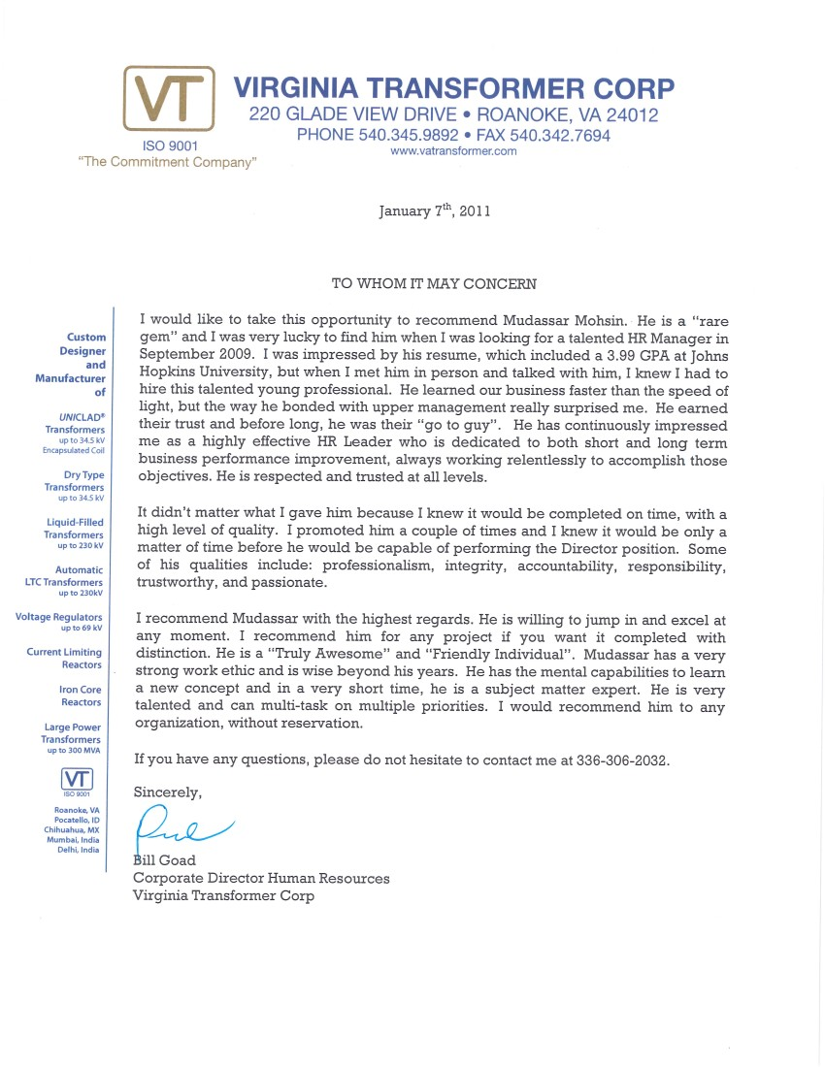

MUDASSAR MOHSIN (PHR)
Cell Phone: (571) 277-8175 • mam_mohsin@yahoo.com
(Permanent Resident of the United States of America)

Visionary, enterprising, profit-focused, and results-driven human resource/ organizational development manager with experience in domestic and international recruitment, employee development, HRIS, regulatory compliance, union negotiations, organizational realignment, and organizational analysis. Adept in strategy development and change management. Successfully Passed PHR Certification Exam, June 2009; Candidate for GPHR Certification in Dec 2011.

• 360-degree Coaching • Strategic HR Management
• Systematic Interventions • Motivation Enhancement Initiatives

PROFESSIONAL EXPERIENCE
Human Resource Manager
VIRGINIA TRANSFORMER CORP (VTC), Roanoke, Virginia • (September 2009- PRESENT)
Privately-owned company that is a leading manufacturer of electrical transformers, reactors and allied power equipment in the United States. VTC employs some 600 individuals and generates annual income of about $150 million.
- Administered and managed the employee experience for on-boarding (corporate and international), assessment process, employee development, background investigations, HRIS, recruiting, learning, benefits, compliance, compensation, domestic relocation, international training & assignments, visa administration.
- Managed a team of 4 individuals, reinforced and streamlined the HR processes.
- Worked closely with the President & key Sr. Leaders to advise and resolve staffing and HR issues and to deliver critical talent needs.
- Worked with diverse teams across geographic location, time zones and cultures, managing key priorities to retain best talents
- Designed & Implemented training & Performance programs for domestic and international professionals
- Immigration – managed both nonimmigrant and immigrant related issues including H1-B, L1-B visa and permanent resident status

Key Accomplishments:
- Have been promoted twice based on outstanding performance and achievements within 18 months of joining the company.
- Successfully Staffed/Recruited several Senior Management professionals that includes and not limited to Sales Director, Engineering Managers & IT Project Managers for U.S locations.
- Initiated the most cost efficient e-Recruitment practices and activities through New Delhi (India) office partnering with Monster India, LinkedIn and Naukri.com
- Reduced international travel & stay expenses of engineers and other professionals by more than 30%
- Reduced non-immigrant visa costs of professional engineers by 50% through eliminating high cost attorney services & developing in-house expertise to handle cases.

Selected Awards
- Received a “Certificate of Commendation” from the President for preparing a strong case (in-house) and getting the corporation the prestigious Blanket L1 Status from U.S immigration.
- Received “Virginia Transformer Corp 2010 Special Award” for company’s most outstanding employee.

Urdu Language Test Evaluation Expert
SOS INTERNATIONAL LTD, Reston, Virginia • (contract project-- September 2008)
Company that has supported the U.S. defense, intelligence, law enforcement and diplomatic communities since 1989.
MUDASSAR MOHSIN (PHR)
• PAGE 2 •

- Evaluated Urdu language proficiency tests for a SOS International project in its operational headquarters.
- Presented the final version of evaluation report to the project manager and advised him based on the evaluation results.

Human Resources Student Consultant
USA TODAY, McLean, Virginia • September 2007- April 2008
National U.S. daily newspaper with widest circulation of all American newspapers.
- Developed coaching, counseling, and mentoring training sessions for supervisors and department managers.
- Authored/administrated 90-day Employee Satisfaction Survey through automated web based tools & major impact in development of company’s Career Website.

Banking Center Associate

BANK OF AMERICA, Arlington, Virginia • October 2004- August 2005
Largest commercial bank in U.S. by deposits and market capitalization with $74B in revenue.
- Exceeded all quarterly sales targets.
- Increased customer-based revenue through needs identification initiatives.
- Developed/implemented banking center efficiency initiatives.
- Ensured regulatory compliance.
- Participated in all efficiency/effectiveness/technical update meetings.
- Recognized by Banking Center Manager for job performance excellence.

Assistant Manager
BEN’S CHILI BOWL, Washington, D.C. • February 2002- 2009
Historic landmark restaurant.
- Increased profits & customer satisfaction endeavors through developing employee training.
- Boosted productivity/employee morale through implementing accountability systems.

EDUCATION/TRAINING

Professional in Human Resources (PHR) (HRCI- June 2009)

M.S in Strategic HR & OD (Summa cum Laude—3.99 GPA)
Johns Hopkins University, Baltimore, Maryland

Selected Projects:
Analysis of US OPM’s Human Capital Initiative for Fiscal Years 2004-07

B.S in Accounting (Honor Role—Dean’s List)
Strayer University, Washington, D.C.
COMPUTER SKILLS

Windows Vista • Windows XP-Home/Pro • MS Office Suite • Adobe Illustrator • Familiar with SPSS, HRIS

KNOWLEDGE OF LANGUAGES

• English (R/W/S) • Hindi (S) • Punjabi (R/W/S) • Urdu (R/W/S) • Arabic (R/W)

PROFESSIONAL MEMBERSHIPS & AFFILIATIONS

Society for Human Resource Management (SHRM)
American Society for Training and Development (ASTD)
MUDASSAR MOHSIN (PHR)
• RECOMMENDATIONS FROM WWW.LINKEDIN.COM •

9 people have recommended Mudassar Mohsin on LinkedIn

"Mudassar was a pleasure to work with in his capacity as Manager of Human Resources. He is one of those unique Human Resource managers who understands the business, its needs, and the relationship with human resources. He is a problem solver who works to solve the problems so all win. I would recommend him to any organization who needs a human resource manager."
— Tom Douglas, Director, Business Development, Virginia Transformer, worked with Mudassar
Mohsin at Virginia Transformer Corp -- US & India (2011)

"Mudassar has a very strong work ethic and is wise beyond his years. He has the mental
capabilities to learn a new concept and in a very short time, he is a subject matter expert. He is very talented and can multi-task on multiple priorities. I would recommend him to any organization,
without reservation."
— Bill Goad, SPHR, GPHR, RCC, Director, Human Resources, Virginia Transformer
Corp, managed Mudassar Mohsin at Virginia Transformer Corp & VT India (2011)

"Mudassar exhibits all of the necessary requirements to be a successful Human Resource
professional. More importantly, he possesses a "keen business sense" that enables him to
understand your needs and present strong, viable options for solutions and improvements. He is
knowledgeable, enthusiastic and hard working. This all leads to him being a valuable resource for
Virginia Transformer."
— Phil Tribel, Director of Sales and Marketing, Virginia Transformer Corp, worked with Mudassar
Mohsin at Virginia Transformer Corp -- US & India (2011)

"Mudassar was of great assistance helping the Accounting Department identify skilled
replacements when we really needed to have positions filled. He also assisted with interviewing an
making offers; he was a great resource."
— Stephen Helfrich, Assistant CFO, Virginia Transformer Corp, managed Mudassar Mohsin
indirectly at Virginia Transformer Corp--US & VT India (2011)

"Mudassar is a hard-working individual that does what is needed to make sure the job gets finished
correctly the first time. He is very detail oriented as well."
— Jeff Wasden, Sales Engineer, Virginia Transformer Corp, worked with Mudassar Mohsin at
Virginia Transformer Corp--US & VT India (2011)

MUDASSAR MOHSIN (PHR)
• RECOMMENDATIONS FROM WWW.LINKEDIN.COM •

"Mudassar is a pleasure to work with. He is a very capable professional as well as friendly and
courteous. His expertise is evident and has already allowed him more opportunities, his abilities
have made him a valuable liaison in H.R., his character and enthusiasm is an asset to his
department and the company. It's been a privilege to get to know Mudassar and work with him.
— Ben Nicely, Graphic Designer/Marketing, Virginia Transformer Corp, worked with Mudassar
Mohsin at Virginia Transformer Corp--US & VT India (2011)

"I very much enjoyed my time working with Mudassar! He is an energetic HR professional who
always seeks solutions to problems and drives for quality in everything he does. Mudassar is
personable and maintains a strong bias toward producing results and a strong work ethic. It is my
pleasure to recommend him and I look forward to watching his career continue to excel!"
— William Rice, SPHR, Corporate Organizational Development Manager, Virginia Transformer
Corp., worked directly with Mudassar Mohsin at Virginia Transformer Corp (2010)

"This letter is my personal recommendation for Mudassar Mohsin. Until recently, Mudassar had
been working in the Human Resources department of USA TODAY as an intern. He took charge of
and completed many important projects while he was with us, including an online Employee Exit
Survey and Coaching course. I found him to be consistently pleasant, tackling all assignments with
dedication and a smile. I highly recommend Mudassar for employment. He is a team player and
would make a great asset to any organization. Thank you,
— Holly Kikel, HR Coordinator, USA TODAY, worked directly with Mudassar Mohsin at USA
TODAY (2008)

"Mudassar is an ambitious and energetic individual who is focused on achieving his goals in life. I
had the privilege of taking some courses with him at JHU and found him to be a determined
individual with leadership potential and strong interpersonal skills. He aspires to be an HR
professional and I wish him success all the way."
— Abu Bakar Siddiq Alvi, Student, The Johns Hopkins University - Carey Business
School, studied with Mudassar Mohsin at The Johns Hopkins University - Carey Business School (2008)

Contact Mudassar Mohsin on LinkedIn: http://www.linkedin.com/in/mammohsin

